23/10/2020

CMP4271 Professional Practice for Games Development

Task 4 – Strategic or Twitch Skills

4.0 Introduction

The premise was to create a game which focused on either Strategic or Twitch skills to be played and tested within the group. The game created was following the Strategic Skills game called Snakey Bomb Game, where the players would work together to defuse a bomb. The player count would be two players minimum.

4.1 Materials

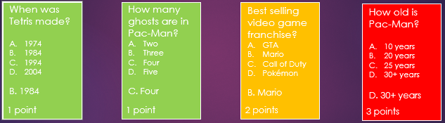

Figure 4.1 Trivia Cards. Used by the Bomb Master to ask the Players and help defuse the bomb.

Pen and Paper to keep score

4.2 Rules

* At the start of the game all the players come together in a team, and one player is chosen as the on-call bomb master.
* All the players then roll a dice to determine what order they go in (highest go first, lowest go last).
* Players take turns to answer questions which are picked randomly by the bomb master after choosing what difficulty of a question they would like to answer, which the players need to answer correctly. Answering it right will help defuse the bomb and answering wrong will make the team lose a life.
* If all lives are lost, then the bomb blows up.
* There are 10 points in total that the players need to receive in order to win, however for each player added, an extra 5 points would be added to increase difficulty.
* If a single player reaches 10 points alone, they have the chance to use those points to 'leave' the bomb room as a single win and take five points with them, leaving the rest of the team to defuse the bomb. For each player added, the cost will go up by 2 points.
* If you manage to answer enough questions right and get the needed points as a team, then the bomb is diffused.

4.3 Playtesting

There was no real issue with the game and was found fun to play. However, it was noted that if you decide to betray your teammates and take all of your points with you, then it makes it impossible for the other players to win. Instead, it was changed so if a player decides to leave the rest of the team, only five points get taken.

4.4 Discussion

From creating the game, what was learned was that the game could be fun, especially when you are on low health. It is also fun to betray your friends, but it is hard to get to that point as you would need ten points independently. However, that just makes the game more about teamwork and reliant on each other to defuse the bomb and win.

4.5 Reflection

The team I worked with was Jack Collins and Ben Miller. What I would do differently would be making sure we have enough time for better playtesting for the game so we could make sure our game worked great.